BARNET ALLOTMENT FEDERATION

ALLOTMENT SELF-MANAGEMENT – THE BARNET PROCESS

In 2013, Barnet Council devolved full responsibility for managing the allotment sites in the London Borough of Barnet to the allotment societies occupying them through 38 year leases on each site. This paper describes the 7-year process by which this result was achieved, though there are still some loose ends to finish off.

The outcome was a deal which allotment societies felt able to accept and which, in effect, matched fairly well the arrangements which the allotment community had envisaged at the outset. The process itself however was unsatisfactory in a number of respects.

This account has been written in case the experience of the allotment community in Barnet can be of help to others round the country as they move towards self-management.

The Old Allotment Scene in Barnet – up to 2013

The London Borough of Barnet is comparatively well-endowed with allotments. The Council owned 44 sites, comprising some 30,000 poles of cultivated ground (equivalent to 3,000 standard 10 pole plots, or around 200 acres/85 hectares) with about 3,200 allotment holders. There are also a number of privately-owned sites in the borough.

For all the Council-owned allotments, the Council set the rents but there were three ways in which the sites were managed:
- Leasehold These sites were held by the incumbent allotment society (17 sites, around 50% of the allotment estate) under 6 year leases and individual plots were rented to allotment holders by the society which retained 50% of the rents. In return for this discount, the society managed the site except for fences, gates, hard roads, plumbing and trees which remained the responsibility of the Council;
- Self-collect On these sites (14 sites, around 33% of the estate) the Council let plots direct to allotment holders and was responsible for site maintenance. The allotment society collected rents, retaining 25% as commission, managed the waiting list and filled vacancies. Many societies also carried out minor repairs;
- Direct Let Here (13 sites, around 17% of the estate) the Council let plots to allotment holders, collected rents directly and was wholly responsible for maintenance. A local site representative managed the waiting list and filled vacancies. On some of these sites, there was no organised allotment society.

The Barnet Allotment Federation

The Barnet Allotment Federation - formerly, the Barnet Federation of Allotment and Horticultural Societies - was founded in 1965 at the time of local government reorganisation by the merger of federations in Barnet’s predecessor boroughs and districts. By 2000, all 37 allotment societies in Barnet were members. The Federation’s overall aim was a strong and sustainable allotment movement in Barnet and its practical job to represent, inform, support and encourage all the allotment societies and - through them – the allotment holders in the borough.

SELF-MANAGEMENT – MARK I - 2006

In early 2006, Barnet Council approached the Federation with the proposal that it should take over from the Council the management of all the borough’s allotment sites. This approach was agreed by the Council in November 2006. A great detail of preparatory work was done by the Federation in drawing up organisational structures and business plans but the debate hinged on the legal vehicle for achieving the handover. On legal advice, the Council proposed a management agreement but the terms appeared too restrictive with much of the management control remaining with the Council.

For its part, the Federation proposed that the Council should grant a lease to the Federation covering all the allotment sites with the Federation progressively sub-leasing individual sites to the incumbent allotment societies. The Council was advised – incorrectly, as it later transpired – that it lacked the legal power to grant leases on allotment sites to allotment societies. This legal route was apparently blocked and the Federation concluded that it would not be able to run a viable operation under the restrictive terms of the management agreement. The discussions consequently broke down in mid-2008.

In the following two years, there were sporadic contacts between the Council and the Federation. However the Council cabinet member responsible for the subject changed three times and there was no sustained dialogue.

SELF-MANAGEMENT MARK II - 2010

It was not until July 2010 that a new cabinet member announced his intention that allotment sites in the borough would be handed over to the incumbent allotment societies on the basis that “allotment holders know how to manage allotments better than we do”. The Council subsequently adopted this policy in November 2010 though the legal means by which devolution would be achieved – whether a lease or a management agreement – had not been decided.

The Council’s Aims

At the time, the Council saw this new self-management policy as supporting the Big Society - the Government’s theme for making greater use of the third sector in delivering services and supporting communities. The policy was seen as involving the community in running the borough and as devolving service provision and delivery. At the same time, the Council would be able to retain allotment land as physical asset and make a number of staff and other cost savings. There was also scope for the Council to divest itself of a substantial backlog of maintenance and repairs and potentially to hand over other liabilities as well. The backlog was probably of the order £500,000 - £1 million across all the sites with a number of other liabilities on some sites such as currently unresolved encroachments onto allotment property and long-standing breaches of allotment rules.

The Allotment Community’s Aims

Under the leadership of the Federation, the allotment societies in Barnet set out a number of key aims for any self-management deal:
- Security of Tenure A security of tenure of 30+ years was necessary to encourage investment in the allotment sites and to allow societies to apply for grants for improvements and developments;
- Business Viability The terms and conditions of devolution must offer allotment societies an operation they thought was viable, in financial and management terms;
- Management Freedom The societies should have complete management freedom to cope with the extra responsibilities and costs they would face and to run things in ways which worked for each society, subject to basic safeguards for the public interest.

It was clear that to give the allotment community the responsibility, cost and risk of managing their own allotment sites while the Council retained the power and control simply wouldn’t work for the societies. It would also greatly increase the risk to the Council’s self-management policy since more societies would be reluctant to sign up and there would be a greater likelihood that those which did so would collapse under the challenge – in which case the sites concerned would revert to Council management.

Legal Avenues for Devolution

The Council was advised in 2008 that it lacked the legal power to grant a lease on allotment land to an allotment society or cooperative. A previous power under s. 27(6) of the Small Holdings and Allotment Act 1908 as supplemented by s.3 of the Small Holdings and Allotments Act 1926 disappeared when the latter was repealed in 2004. The Council was therefore advised to appoint allotment managers (Barnet Council tax payers) under s.29 of the Small Holdings and Allotments Act 1908, a proposal which lead to the collapse of the first round of discussions.

Enquiries by the Federation which led to a Parliamentary question revealed that the Council could use its general powers to dispose of land under s.123 of the Local Government Act 1972. This provision was later qualified by the General Disposal Consent (England) 2003 which allowed local authorities to dispose of land by lease for any period of years without the approval of the Secretary of State provided that (a) the disposal resulted in an improvement to the economic, social or environmental well being of the area and (b) any loss caused by disposal at less than best consideration did not exceed £2 million.

In the light of this new information, the Council finally opted for this leasehold approach.

The Basic Deal

The basic proposal involved the Council leasing each allotment site to the allotment society occupying it at a peppercorn rent using its powers under the Local Government Act. The societies would have “full management responsibility” for all aspects of their site including maintenance of fences, gates, roads, plumbing and trees. There would be no on-going costs to the Council, no subsidy of the allotment operations and no up-front dowry, though the Council would undertake any repairs which were needed at the start of the leases for health and safety reasons or for legal compliance reasons such as water regulations. Each society would set the level of rent for the allotments on their own site.

The Negotiation Process

There were several components to the process by which the leases of the individual allotment sites were eventually agreed:
- Drafting Group Following an initial consultation meeting at which all allotment societies were represented, the detailed terms of the lease including obligations to be imposed on allotment holders were thrashed out in a drafting group comprising representatives of the Council and the allotment community led by the Federation. The result was a model lease which the Federation was able to commend to the allotment societies and to which they could seek modifications to meet any specific needs;
- Site Inspections A Council team inspected every allotment site to draw up a ‘schedule of condition’ describing both the state of the site at the start of the lease and a list of essential health and safety works to be undertaken by the Council. This process was much delayed and the effect of the delays on the goodwill of many allotment societies was corrosive. Subsequent negotiations between the Council and each society on the content of the schedules were often difficult, not least because some of the defective items identified during the surveys appeared to have been edited out of final survey reports prepared by the Council;
- Site Valuations The value of each site was assessed by the Valuation Office Agency in order to establish whether the Council could make use of the General Disposal Consent in leasing out the sites. All were found to have only nominal value and the consent was used in all cases.

The atmosphere for the negotiations was soured by an attempt by the Council to impose substantial rent increases – between two- and eight-fold. The Council’s first attempt to implement these increases was defeated by allotment holders’ threat of legal action. The second attempt was directed at any societies which did not agree to self-management by various arbitrary deadlines. Many in the allotment community felt that that they were being bullied into accepting self-management on terms set by the Council – a feeling made worst by the long delays in carrying through the programme of Council site inspections. In the event, all societies felt they were able to accept self-management on the terms eventually negotiated and none had to pay the increased rents.

Tricky Issues

Some of the more difficult core issues during the negotiation of the model lease included:
- Lease Term Securing a long enough lease term required some intensive discussion to increase an initial Council proposal of 6 years to a more reasonable 38. The General Disposal Consent was an important tool in securing a term longer than 7 years, the previous trigger for Secretary of State approval. The Council opted for 38 years to avoid the threshold of 40 years after which tenants could apply to the Land Registry to have some covenants in a lease set aside if there were a suitable case;
- Full Management Responsibility The allotment societies required the essential minimum of scope for Council intervention. Some within the Council seemed to hanker after retaining some management controls even though Councillors had agreed they wished to retain little beyond the power to reclaim un-used land;
- Termination Clauses The Council had indicated it wished to dispense with its task of managing allotments permanently and the termination clauses in the lease had to be drafted appropriately, without language that effectively turned the lease into an annual rolling tenancy. The latter would have had a disastrous effect on the societies’ ability to raise grants as most fund givers require security of tenure, and on the willingness of society members to invest time, effort and money in their site;
- Under Occupied Sites A formula was eventually agreed whereby sites with more than 25% of plots vacant for three consecutive years would be subject to a development plan agreed between the society and the Council. If this failed to restore occupancy levels within three years, then the Council could re-claim the unused land;
- Health & Safety Repairs The Council committed to carry out essential health & safety repairs within a reasonable time following the start of each lease. Each allotment society carried out its own negotiation with the Council about what repairs were needed.

Amongst more specific issues were:
- River Banks Riparian responsibilities include maintaining the river bank and half of the river bed for those sites bordering waterways. While some societies might be willing enough to keep the bank of a waterway tidy as a goodwill and good-housekeeping measure, the full range of riparian responsibilities would have been onerous and potentially expensive for societies and these duties now remain with the Council;
- Asbestos Nearly all sites had some asbestos cement and this included Council-owned buildings to be handed over to allotment societies. The Council commissioned a specialist survey and undertook to remove any asbestos identified as being hazardous;
- Trees Responsibility for trees was an issue for some societies, particularly veteran trees such as oaks which probably marked the original field boundaries a century or so ago. Some of these were in dubious condition and would represent a major liability for allotment societies if inherited from the Council without prior treatment. A good deal of such arboricultural work was to be done by the Council as part of the deal.

The negotiation of the model lease was an efficient process with the Council team led by a senior manager. However, there were problems and delays in the roll-out to the allotment societies and there were a number of persistent problems with the implementation of the self-management policy.
- Communication and Engagement Communications by the Council with the allotment community (both the Federation and the individual societies) was generally poor. The community were only told sporadically of the Council’s roll-out plans and timetables, and enquiries from societies sometimes went unanswered for long periods until a programme coordinator and dedicated solicitor were appointed by the Council in May 2013. The Council then applied pressure on societies to sign up to lease deals by setting arbitrary deadlines with the threat of imposing major rent increases on any laggards. In the event, these threats came to nothing;
- Delays In Implementation There were persistent and cumulative delays in implementation, especially in carrying out the programme of site inspections. The Council published at least four timetables and the final leases were not signed until November 2013 – 18 months later than the original target and seven years after the Council first approached the Federation to discuss new management arrangements. At the time of writing (October 2014) there is still one lease outstanding because the Council has not taken the necessary steps to register the land with the Land Registry.

SUPPORT FOR THE ALLOTMENT SOCIETIES

It was apparent to the Federation from the outset that many of the allotment societies would need significant support to improve their management competencies and capacity if they were successfully to manage their own sites and to manage themselves as independent, self-financing organisations. The Federation estimated that providing such support would require a suitably qualified and experienced person working about half-time in the run-up to handing over the sites and the early period thereafter. This was quite beyond the capabilities of the Federation’s own volunteers.

In 2012, the Federation applied for and secured a £16,000 grant for a support officer in a Barnet Council open competition for innovative ideas in delivering public services under the Big Society banner. The support officer post was advertised nationally through a jobs website and locally through the allotment societies. Out of 20 candidates, the successful applicant was a local candidate with many years’ experience with voluntary organisations and a good knowledge of the allotment scene in Barnet.

In the event, delays by the Council in implementing the self-management programme meant that the grant ran out before most sites had been handed over and a second grant of £9,000 was secured from a general Council grant scheme for voluntary and community organisations.

The core elements of the support officer’s job were:
  - To boost the competence, capacity and standards of allotment societies in governance, management and finance;
  - To develop guidance on a range of management, financial and allotment issues and provide suitable management tools e.g. planning spreadsheets;
  - To deliver bespoke advice and support to individual societies.

Over the 27 months of the grant period the support officer put in some 1,700 hours of chargeable work, logged some 2,000 separate actions and produced some 30 guidance and other documents ranging from model constitutions to advice on riparian issues. He also brokered the adoption of three of the smallest allotment societies by larger neighbours, with the agreement of all concerned.

The officer also conducted three annual surveys of the societies, allowing him to monitor their progress in improving some key indicators of their competence – and providing the Council with evidence of the effectiveness of their grant funding.

The progress achieved by the societies over this period is summarised later.

LESSONS LEARNED

The Two Alternative Models for Self-Management

The first approach proposed was for the Council to hand over management of all the sites to the Federation which would have progressively delegated management to the individual allotment societies. The advantage of this would have been that the Federation could provide tapered management support for those societies which were least ready for independent operation plus a safety net (financial and otherwise) for any that subsequently got into trouble. On the other hand, the Federation would have had to charge the societies a substantive rent in order to finance the administrative support and financial back-up this approach would have involved.

The second approach – direct delegation from the Council to societies – involved more of a challenge for societies as they faced a step change in how they did business. The Federation would not have a formal role as intermediary landlord in providing substantive support. On the other hand, the peppercorn rent charged by the Council allowed societies to keep all their income themselves – important in financing long term maintenance and renovations. Moreover, the grant-funding secured by the Federation for the support officer meant that substantial, high quality advice and guidance was available to societies as they prepared for the hand-over and in the immediate aftermath.

Despite first appearances, the second approach delivered a very similar outcome to the first – independent, self-financing societies with access to advice and guidance. To support this outcome, the Federation has changed its objectives from being largely an interface between the allotment community and the Council to being a support organisation helping societies to learn from each other and from the wealth of experience and expertise available elsewhere.

Check Everything

In the processes of negotiation between Council, Federation and societies, it was crucial to obtain independent advice on key issues wherever possible. For example, the Council’s legal advice that it lacked the legal power to grant leases to allotment societies was only shown to be mistaken when the Federation made its own enquiries through parliamentary contacts. On other issues of fact as well as law, the Federation found it important to do its own research so as to validate (or otherwise) the points being put to it and to the allotment societies during the negotiations.

The allotment societies also found it important to check all the details of their draft leases for mistakes, oversights, and inconsistencies. This was particularly significant since the Council was producing a large batch of leases which differed from each other in small but critical details. For example, several leases were subsequently rejected by the Land Registry when they were submitted for registration because the land title numbers were wrong or the plan of the site was drawn to the wrong scale. Careful checking by the Council - as well as the society concerned - could have spotted some of these problems at draft stage when they could easily have been remedied.

Consistency of Approach

On the side of the allotment societies, the Council’s uncompromising approach to imposing self-management and the threat of large rent increases to recalcitrant societies served as a strong unifying influence. There was almost unanimous support for the Federation’s approach to the negotiations with the Council, even when some societies were impatient for a more aggressive tactical line than the Federation leadership was recommending. In the event, the Federation’s more patient and diplomatic style delivered an outcome which all the allotment societies found they could accept, given the difficult circumstances created by the Council. For example, no allotment society was charged the proposed higher rents and only one allotment site (with 4 plots, one tenant and a large derelict area of fly-tipping) remained in Council management.

On the Council side, the early stages of the negotiation showed an apparent divergence between, on the one hand, the attitude of councillors who wished to hand over the sites with few strings attached and, on the other, the attitude of some officials who seemed reluctant to surrender the power and control which they had previously exercised. This latter attitude may have been well-intentioned – the allotment community accepted, for example, that essential safeguards for the public interest would have to be part of the deal – but it was not what the Council itself had agreed.

A second factor on the Council side was poor coordination amongst the Council departments involved – parks, property and legal. This resulted partly in differences of view over issues but, more critically, caused persistent and long delays as one department waited for another to give the self-management programme sufficient priority, especially during the implementation of the hand-overs. Only when a dedicated programme coordinator and a dedicated lawyer were appointed was serious progress made. The downside of this more active management was that the Council then sought to rush societies into taking decisions over the terms of each particular deal by setting arbitrary deadlines with the threat of rent increases for those who didn’t comply.

These inconsistencies of approach had a damaging effect on the attitudes of the allotment societies towards self-management. It also made it more difficult for the Federation to maintain a calm and business-like approach on the part of the societies who alternately felt frustrated at lack of progress and then bullied to sign up to a deal they might not be happy with.

Taking a Balanced View

Each side in the negotiations had to accept – with more or less difficulty – that the other had issues on which it could not compromise. For its part, the Council required a basic minimum of safeguards for the public interest and the allotment community came to accept that. Equally, there were certain key conditions for the allotment societies – long lease, freedom from micro-management, a minimum backlog of repairs - which the Council had to accommodate if there was to be a deal at all.

One of the more difficult points to get to grips with was a counter-intuitive one. Normally each side can seek to be as tough as possible in negotiating the terms of a deal. But in this case, it was in the Council’s own interest to find a deal which the allotment societies could live with because the tougher the terms, the more likely it was that the societies would fail as independent self-supporting entities in the longer term. If they failed, then the Council’s own policy of self-management would have failed.

Management and Deadlines

There were major problems on the Council side in rolling out the self-management programme in a well-managed and timely way. At least 5 Council deadlines came and went with little sign of progress and then progress, when it came, was rushed. On the other hand, the negotiation of the model lease was closely managed on the Council side as well as the Federation and progress was rapid.

The lesson of this seems to be that for a significant programme involving 37 different allotment societies, both Council and allotment community need to have programme managers with the authority and/or seniority to make things happen.

Communication

In order to maintain good will as well as progress, both sides need to keep in touch with each other. This is particularly important if there are problems or hiccups along the way. Too often, allotment societies found that the Council failed to respond promptly (or at all) to enquiries and there were long periods when no substantive information was available about progress or plans. Such failures tend to harden attitudes and make constructive negotiations more difficult. In this case, it also made it very difficult for allotment societies themselves to plan their own annual business such as collecting rents since they did not know when the new lease with its new provisions would start.

Two different communication channels were important in the negotiations. First, the formal channel through which proposal and counter-proposal are made as part of the formal negotiation. Second, an informal channel – in our case between the Federation co-ordinator and the lead Council official – which can be used for keeping up to date and to test out “what if” scenarios. This can be tricky across the formal negotiating table even on a “without prejudice” basis unless there is complete trust between the two sides. This informal channel was used to discuss a number of general issues affecting all allotment societies such as the start date of the new leases and arrangements for collecting rent in any interregnum caused by back-dating the lease, and to test out solutions to problems involving individual allotment societies where formal discussions with the Council had reached an impasse.

Support for the Allotment Societies

Negotiating a basic deal contained in the model lease and rolling out the programme of hand-overs was only half the job. The other essential half was to give the allotment societies enough support and guidance:
- To grasp the issues addressed in the overall deal and its implications for them;
- To conduct an informed negotiation of the site-specific terms of their individual leases;
- To be confident that they could tackle the issues they would face once independent;
- To handle specific technical tasks falling to them such as registering their new leases with the Land Registry.

Without this support, it is doubtful whether the some of the allotment societies would have had the confidence or capability to take on self-management.

PROGRESS MADE BY THE ALLOTMENT SOCIETIES

During the Spring of 2012, 2013 and 2014 the Support Officer issued a questionnaire to all the allotment societies. Initially this was to provide basic data about the sites and societies and establish a baseline from which later changes could be measured. The later surveys showed the changes happening and informed the Support Officer which societies required additional advice and on what topics. Not every society answered every question every time but, with telephone conversations and site visits, a nearly complete picture was obtained each year.

Governance

A major problem in 2012 was that not every site had a society and many societies were in an embryonic state. Even societies which had held a lease for many years and were well used to running their sites and themselves were, in many cases, lacking some of the hallmarks of good governance. To accept the greater powers to run the allotment service which was on offer with a much increased financial turnover it was essential that the societies raised their standards.
- Constitutions In 2012 seven societies were registered as Industrial & Provident societies and these all remained with this structure. Of the remaining thirty societies all were unincorporated associations, eight without a written constitution and the remainder with inadequate constitutions. One society opted to become a Company Limited by Guarantee and the remaining twenty nine adopted the model constitution promulgated by the Federation.
- Committees In 2012 every society except one had an elected committee and in 2014 they all did. In 2012 14% of societies lacked written committee paperwork. In 2014 none of them lacked this.
- Strategic Planning From 2012 to 2014 the number of societies with written long term plans rose from one to sixteen of the total of thirty seven.
- Communications From 2013 to 2014 the number of societies with a website rose from 15 to 20. Most societies have been actively considering how they communicate with their members and the public with many introducing newsletters, installing new notice boards and acquiring a society telephone number and e-mail addresses.
- Financial Control In 2012 8% of societies lacked a bank account in the name of the society, and 19% had their funds under single signature control. In 2014 every society had a bank account in the society’s name and only two societies had single signature control which both societies were in the process of changing.
- Accounts and Independent Inspection In 2012 eight societies had no written annual accounts. In 2014 this had dropped to two and they were intending to produce them. In 2012 almost half of the societies did not have their annual accounts independently inspected. In 2014 this had reduced to one third and they were all intending to obtain independent inspection in future.
- Insurance In 2012 29% of societies had no insurance. In 2014 every society had public liability and employer’s liability insurance.

It is anticipated that over the next 2-3 years societies will consolidate these improvements in their governance. In particular they will all need to develop costed and programmed long term plans if they are to take control of their future.

Cash

Because allotment societies cannot obtain commercial loans their cash holding is crucial to their ability to survive crises and to fund improvements to their sites. Indeed, as the following information shows, a shortage of cash amongst the allotment societies is unquestionably the biggest single threat to the success of the self-management policy. In every society the first call on cash is the money needed to operate the site, doing the basics like paying for the water, insurance and minor repairs. The second call on the cash is an emergency reserve to cope with the unexpected and pressing unplanned expenditure such as dealing with a water leak or fallen tree. Remaining cash can be designated for future projects such as renewing the fences.

At the start of self-management the cash holding of societies varied widely from tens of thousands to a few hundred pounds. The Federation has advised that larger societies (more than a hundred tenants) need an emergency financial reserve around £15,000, medium societies (50-100 tenants) about £10,000 and smaller societies (below 50 tenants) not less than £5,000.

The societies have been very alert to this issue and most of them have taken steps to increase their cash holding. Total cash holding of all the societies rose in the year from Spring 2013 to Spring 2014 from £345,000 to £490,000. Progress is illustrated in the chart below which shows how the societies have been increasing their cash (shown here per plot holder) especially amongst the poorer societies at the right hand side.

On the following charts each point on the coloured lines shows one society and for each year the societies are simply ordered according to their cash holding. Thus the coloured lines do not show the changes in individual societies but the contrast between the different lines show changes to the societies as a whole.

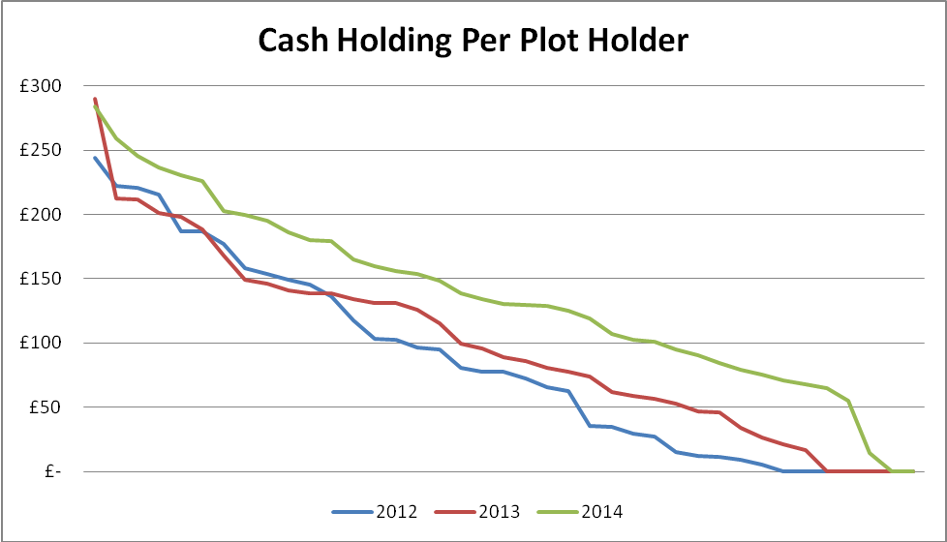

The following three charts show how the total cash held has changed over the period 2012 to 2014 for small, medium and large societies. This division by size is based on the number of plot holders of each society – small being up to 50 plot holders, medium being 51-100 plot holders and large being over 100 plot holders. In each case the total cash holding is compared to the thick black line which is the Federation’s recommended minimum emergency fund for each size of society. Of course the total cash includes cash for running costs and any planned future projects as well as emergency costs. It can be seen that in all three sizes of society there are many societies with considerably less cash than is prudent, and this is more acute for smaller societies than large ones. The total deficiency of cash across all the thirty seven societies is estimated to be in the range of £100,000-300,000.

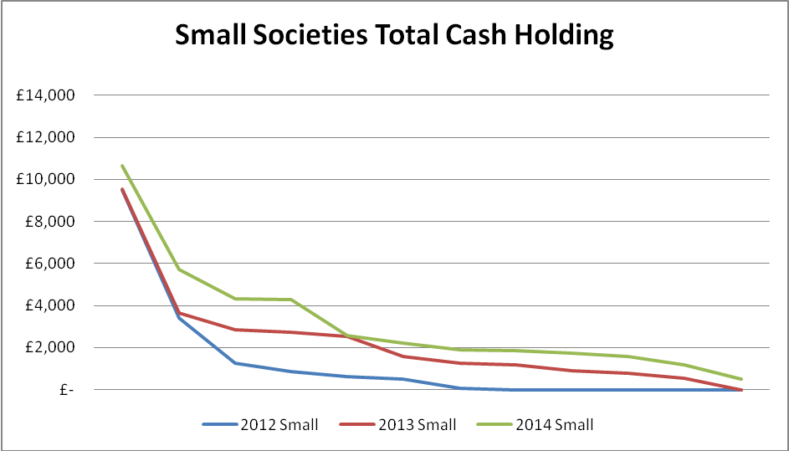

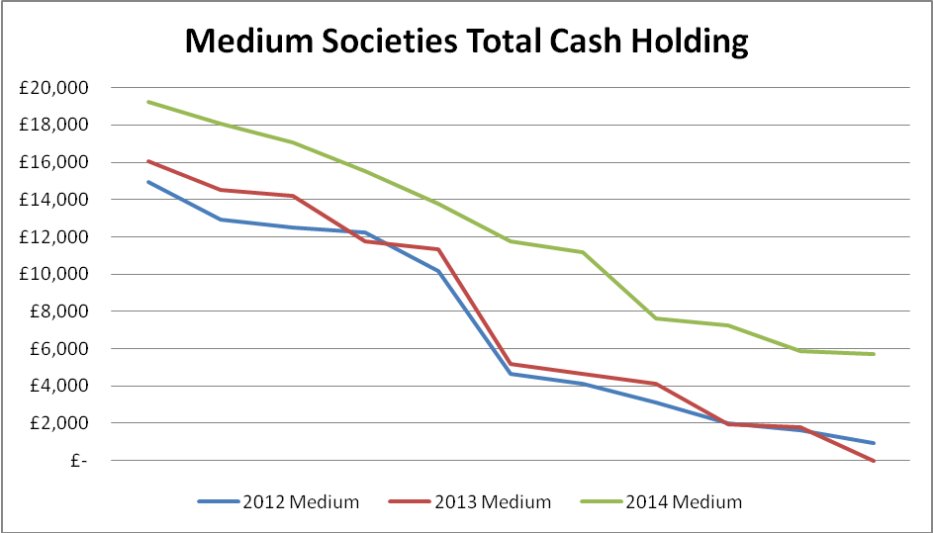

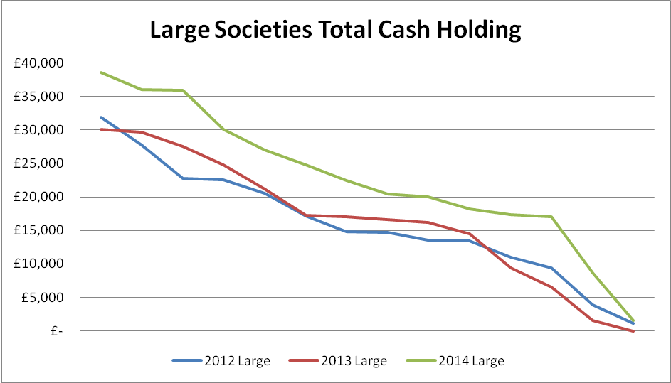

The Council chose not to pump prime cash poor societies with an initial endowment and this has left many of them exposed to future crises and at significant risk of failure, at least until they can accumulate enough cash. This situation is exacerbated by the fact that the Council bequeathed a very substantial backlog of maintenance to many of the societies. Accumulating enough cash is particularly difficult for small societies because of their limited income stream. It will be interesting to see how many of the smaller societies fail because of a cash shortage over the next few years. Whilst there is always the possibility of a merger with a larger society, the shortage of cash coupled with the backlog of maintenance will continue to threaten the success of the Council’s self-management policy for years to come.

Income

The first of the following charts shows the gross income of each society expressed per pole of lettable land and the second shows the income per plot holder. For most societies the bulk of their income is from allotment rents. The societies with large incomes from other sources at the extreme left hand end of the charts can be ignored. The importance of these charts is that they clearly show the overall increases in income, particularly rents, during the period 2012 to 2014, and this is most marked amongst those at the right hand side of the chart which started with a lower income.

Allotment societies and their plot holders are not averse to increasing rents provided they have confidence in the management, there are sound reasons for the increase, and they have the reasons for increased rent properly explained.

Again, each point on the coloured lines of the following charts shows one society and for each year the societies are simply ordered according to their annual income. Thus the coloured lines do not show the changes in individual societies but the contrast between the different lines show changes to the societies as a whole.

The societies shown as having zero income for the earlier years are those whose sites were wholly managed by the Council, on which the Council collected the rent directly from the plot holders without any involvement by a society.

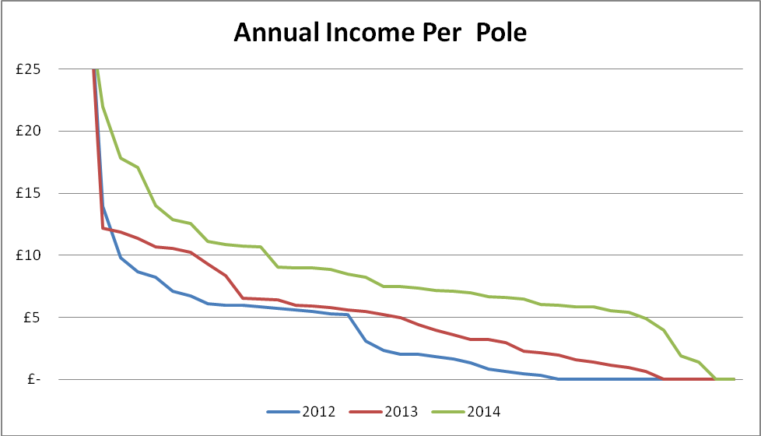

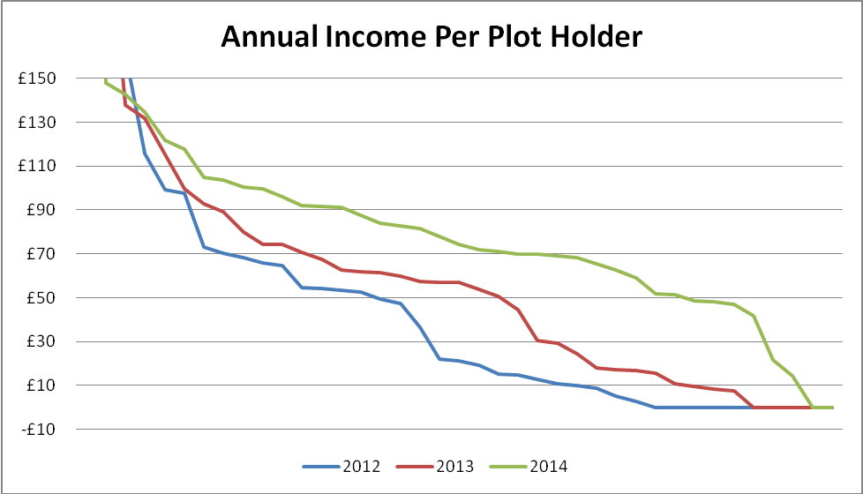

Allotment Rents

Historically the Council set the same rent per pole for all of its allotment sites and, until recent years, subsidised the allotment service. Some years ago there was a decision made to stop subsidising the service but rental income failed to compensate for this and the result was an increasingly poor service and an increase in the backlog of maintenance. With the introduction of self-management societies were freed to set the level and structure of their charges.

Almost all of the societies are facing a substantial backlog of maintenance and have ideas for improving their sites and their services to their plot holders, and there has inevitably been a general increase in allotment rents. Many of the sites which were directly managed by the Council have societies which have had little opportunity to build up cash and often these are on smaller sites with a limited income stream. These are the societies which have been quickest to raise rents and by substantial amounts. In 2014 rents varied from £5.00 per pole to £18.00 per pole with a modal average of about £10 per pole. This wide spread of rent levels is likely to be temporary as larger and richer societies which have not felt obliged to raise their rents dramatically will probably increase their rents, albeit more slowly and by lesser amounts.

The standard Council rent included a 50% discount on the first ten poles of land for tenants over 60 years of age. This discount was intended as a poverty relief measure, one of the historic purposes of allotments, but, with the incomes of older people now varying very widely, a poverty discount based solely on age is very poorly targeted. Furthermore, with about half of the borough’s plot holders being over 60 years of age, this discount was costing the societies around a quarter of their income. By 2014 only twelve of the 37 societies were still applying the Council’s discount. Nine societies had scrapped the discount completely and sixteen societies had modified the discount to limit the loss of income. In most cases this modification is the first step towards progressive abolition of age-related discount. The experience of the societies has been that reduction or abolition of age-related discount has been agreeable to their members of all ages as there is general recognition that the discount is unfair to younger people. Older people lost little individually as the maximum discount was about £30 per plot holder per year.

Tenants

Every society’s tenants (it’s plot holders) are members of that society and elect a management committee from amongst themselves. Every society now has written rules and a signed agreement with each tenant. A significant number of societies acquired with their new leases a backlog of persistent misbehaviour by a few tenants and all affected societies are now dealing with these problems. Some societies had a written complaints procedure previously but all societies have now revised this situation and almost all have a new complaints procedure. The Federation now offers societies a service of independent review of their complaints, if societies are unable to supply an independent reviewer themselves.

Volunteers

The economics of allotment societies are such that it is very advantageous for them to utilise volunteers (mainly their plot holders) rather than contractors for most requirements. The societies recognise this and some have started to systematically record the relevant skills of their plot holders as a foundation to fully utilising the skills they already have available. More societies than previously now run work days when plot holders work for the society rather than on their own allotment plots. Some societies have appointed officers specifically to manage their volunteers. Developing their volunteers will have an impact on the societies’ capacity to achieve their objects which is as important as developing their income and increasing their cash holding.

The Federation

During the self-management handover the societies not only reformed their own governance but also that of their Federation. Equipped with a new constitution and business plan the Federation is now focussed on supporting the societies in their delivery of self-management. Presently, this is being done mainly by identifying best practice within the societies and spreading this to the others through monthly workshop sessions.

The Future

At the time of writing (Autumn 2014) the allotment societies are still at the early stages of adjusting to self-management. The progress in the first two years which is illustrated above is very encouraging but merely the beginning. Over the next few years the societies are expected to make the following changes:
- Governance Consolidate their governance improvements.
- Planning Produce long term plans with costs and timings.
- Income Raise the income for those plans, partly by grant fund raising, partly by increasing rents and for a few societies by increasing trading profits.
- Cash Increase their cash holding to cover their needs for emergency funds and the cost of future projects.
- Volunteers Improve their ability to get things done by systematically managing their volunteers.
- Learning Work together through their Federation to learn from each other relevant skills for the better management of their societies and their sites.

1 pole = approx 25 sq metres or 30 sq yards
details of the Federation and its work may be found at www.barnetallotments.org.uk
the Council paper is at http://barnet.moderngov.co.uk/Data/Cabinet/200611271900/Agenda/Document%206.pdf
under s. 29 of the Small Holdings and Allotments Act 1908
Council paper is at http://barnet.moderngov.co.uk/Data/Cabinet/201011291900/Agenda/Document%209.pdf
House of Lords Hansard 16 Mar 2011 : Column WA59
the full terms of the final model lease can be found at www.barnetallotments.org.uk/selfmanagement/index.php
subject to the requirement that rent should be ‘reasonable’ – s. 10(1) Allotments Act 1950
The gross income includes not only rents but also water charges, subscriptions, any grants and profits from any trading.
Rent figures include charges for water.

